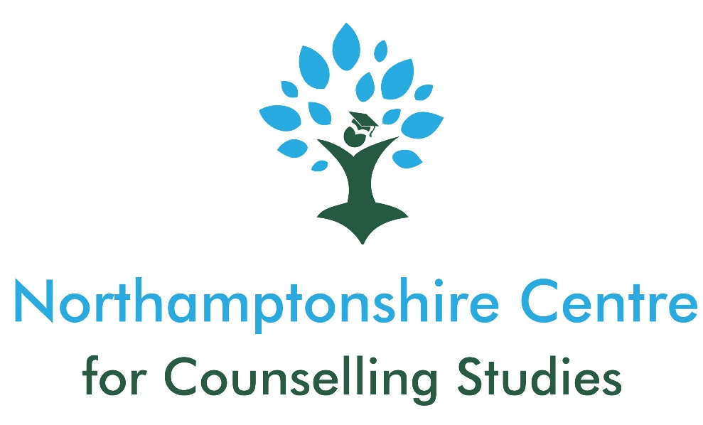

CPCAB LEVEL 3 CERTIFICATE IN COUNSELLING STUDIES (CST-L3)

COURSE INFORMATION

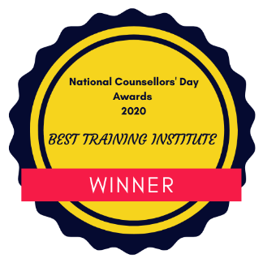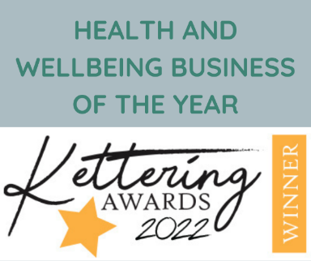

Course Overview
Qualification: | CPCAB Level 3 Certificate in Counselling Studies
Hours: | 90 hours
Fees: | £1389 (including £189 CPCAB registration fee)
Tutor: | Joanna Gilbert
Commencing:  Days: | 10th September 2024  Tuesday (6-9pm)
Location: | Online
Duration: | One academic year
Additional Req. | Minimum of 6 hours personal therapy at own cost
Eligibility: | You must have undertaken counselling skills training e.g. Level 2 Certificate in Counselling Skills or equivalent of at least 90 guided learning hours. Proof of this will be required at interview. If you have not completed this, your application for level 3 will not be considered. If you are transferring from another Centre and/or awarding body, you will be required to submit samples of your Level 2 work and a 15-minute skills practice recording.  Level 2 or equivalent in English Language. If you don’t have this level of literacy this does not preclude you from the course, but you will need to provide evidence of your written skills through use of the written exercise as part of the application process.  Ability to access an online training course including, a confidential space that is free from interruption, good lighting, webcam, wifi connection, good IT skills (including access to Microsoft Office, ability to use Word, fill in proforma templates electronically, attach documents to emails and send, use an online classroom platform).  A willingness to discuss thoughts and feelings with others as part of a group, 1-2-1 with other students and tutors and in writing.  A willingness to undertake a minimum of six hours of personal therapy at your own cost.  A willingness to give feedback to and receive feedback from others in the group.  Be committed to exploring your own values, beliefs and attitudes and examining how you relate to other people.  Be committed to the learning process and completing the necessary homework to fulfil the requirements of the course.  Applicants who are experiencing current emotional or psychological problems will not be accepted onto the course.  Applicants who are experiencing current significant life circumstances may not be accepted onto the course
Interviews: | Begin week commencing 13/05/24 – to be considered for first round of interviews, application documents to be submitted by 22/04/24
How To Apply: (1) Complete and submit the application form and written exercise that can be found on the website
(2) Attend an online (zoom) interview lasting up to 45 minutes
(3) If successful at interview, you will be offered a place on the course pending deposit payments, returned Terms and Conditions and other requested documents

The Training Centre
The Northamptonshire Centre for Counselling Studies (NCCS) is an award-winning counselling training centre - recently winning the Health and Wellbeing Business of the Year at the Kettering Business Awards 2022 and the Best Training Institute in 2020 (National Counselling Awards). It was first established in 2016 and operates in Wellingborough, Northamptonshire for classroom-based courses, and online, (involving live, synchronous, teaching using Zoom).
We are currently working towards obtaining accreditation for the Level 4 course.
In addition to offering counselling courses, Levels 2 – 4, we also offer various CPD courses, such as: Understanding Equality and Diversity Law; Introduction to Listening Skills; Counselling for Chronic Pain/Illness; and more.
NCCS considers itself to be a ‘gatekeeper’ to the counselling profession and because counselling is still an unregulated profession, we take this responsibility very seriously. We have been assessed via internal and external quality-assurance procedures as being a training centre that has high expectations of its students. To enable students to work to these high standards, we also have equally high expectations of our staff and of the courses we provide. We therefore ensure that our courses not only focus on teaching the theory and skills of counselling but also the practical elements of being a counsellor so that we know any fully qualified counsellor leaving the centre can practice safely and ethically.
Our staff come from a variety of backgrounds and their knowledge and expertise cover a variety of different areas including systemic therapy; relationship counselling; addictions; LGBTQ+ issues; working with children and young people; private practice; chronic health/pain; domestic abuse; trauma; and much more.
It is important to us that all tutors are practicing counsellors. This means that they are up to date on current counselling policy and relevant legislation as well as being exposed to a wide range of client presenting issues that inform their teaching practice. Many of the tutors are also practicing clinical supervisors who supervise the practice of other counsellors.
It is important to us that all tutors are practicing counsellors. This means that they are up to date on current counselling policy and relevant legislation as well as being exposed to a wide range of client presenting issues that inform their teaching practice. Many of the tutors are also practicing clinical supervisors who supervise the practice of other counsellors.
Courses are reviewed regularly, and we conduct regular student surveys to ensure that we are making any necessary adjustments and adaptations to courses. We also keep class sizes small:
- 12-15 students (maximum) on Levels 2 3, and 4.
As a private training centre there are some limitations to what we can offer compared to larger training centres such as Further Education colleges or Universities. These include not being able to offer official student funding (e.g., Advanced Learning Loans), a library, cafeteria/coffee shop, unlimited breakout rooms and 1-2-1 specialist support for learning needs.
However, we love that we are a small, intimate training centre and are student-focused, offering that ‘personal touch’ that is outlined in the NCCS values where our students feel important and can have more focussed, direct contact with tutors, other centre staff and the Centre Manager.

The Level 3 Course
The Level 3 counselling studies course offered at NCCS is delivered by experienced tutors, supervisors, and other support staff, who work within, or are familiar, with the counselling profession.
The course content includes: -
- Working with an ethical framework
- The counselling relationship
- Difference and diversity
- Working in a user-centred way
- Counselling theory
- Mental health
- Use of clinical supervision
Our courses don’t just focus on theoretical concepts but also the opportunity for self-development (often through experiential tasks) to enhance your self-awareness so that you can eventually work effectively with clients (should you proceed onto the Level 4 diploma course) and achieve relational depth in your work. We endeavour to create a safe environment in which you feel able to undertake this important reflective work.
The relationship between a counsellor and client is one of the most important factors of successful therapeutic outcomes and at NCCS we make every effort to make courses relational to bring the heart of counselling into the training. On the level 3 course you will gain an introduction to counselling theory, while encouraging self-development.
Personal Therapy
You are required to undertake a minimum of 6 hours of personal with a qualified counsellor who must be a member of a counselling professional membership body. You can find your own counsellor but can seek advice and guidance from your tutors if you are unsure who to choose.
Eligibility Requirements
- To be age 19 years or over
- You must have undertaken counselling skills training e.g. Level 2 Certificate in Counselling Skills or equivalent of at least 90 guided learning hours. Proof of this will be required at interview. If you have not completed this, your application for level 3 will not be considered. If you are transferring from another Centre and/or awarding body, you will be required to submit samples of your Level 2 work and a 15 minute skills practice recording.
- Level 2 or equivalent in English Language. If you don’t have this level of literacy this does not preclude you from the course, but you will need to provide evidence of your written skills through use of the written exercise as part of the application process.
- Access to Microsoft Office in order that tutors can marked your work. The ability to access an online training course including, a confidential space that is free from interruption, good lighting, webcam, wifi connection, good IT skills (ability to use Word, fill in proforma templates electronically, attach documents to emails and send, use an online classroom platform).
- A willingness to discuss thoughts and feelings with others as part of a group, 1-2-1 with other students and tutors and in writing.
- A willingness to undertake a minimum of six hours of personal therapy at your own cost.
- A willingness to give feedback to and receive feedback from others in the group.
- Be committed to exploring your own values, beliefs and attitudes and examining how you relate to other people.
- Be committed to the learning process and completing the necessary homework to fulfil the requirements of the course.
- Applicants who are experiencing current emotional or psychological problems will not be accepted onto the course.
- Applicants who are experiencing current significant life circumstances may not be accepted onto the course
It is important that you have carefully considered all the eligibility requirements before applying for the course. You need to have enough emotional energy and time available to be able to successfully apply yourself to all aspects of the training. A discussion with your current course tutor or personal therapist may help you with this consideration.

Theoretical approach
The core theoretical approach taught at NCCS is Carl Rogers’ Person-Centred approach (PCA). The PCA has a humanistic foundation which in a nutshell believes that we all deserve non-judgemental attention to fulfil our potential in our own time and in our own way.
Rogers’ core conditions of empathy, warmth and unconditional positive regard are believed to be necessary for this growth and change to take place. The relationship between the counsellor and client is also at the heart of person-centred counselling.
Person-centred counsellors recognise and believe that: -
- Each person has the capacity to self-heal and personally grow towards a concept called self-actualisation
- Each person has an organismic self-made up of actual experience and individual awareness and a self-concept which is often described as a distortion of the true, organismic self
- Each person has the potential of higher self-worth if their self-concept and organismic self are more consistent with each other
- The counsellor can create the core therapeutic conditions in their relationship with a client. This is necessary and sufficient for clients to become more in touch with their organismic self, be more able to grow and develop in a healthy way, be more accepting of unwanted aspects of themselves and more ale to make choices
Using the PCA, the courses taught at this teaching centre are experiential in nature with the aim of leading to personal development and change within each student which is necessary for working with clients at relational depth.

NCCS Level 3 Team
Kelly Porch – Centre Manager
In addition to being the course lead and one of the core tutors for the Level 4 diploma course, Kelly is also the founder and Centre Manager of NCCS. In addition to this, Kelly is a qualified Person-Centred Counsellor working in private practice (Kelly Porch Counselling) where she helps clients (individuals and couples) presenting with many different issues. She has a particular interest in the provision of counselling for those who have been diagnosed with a chronic illness/pain and those who are in recovery from addiction.

Kelly is an accredited member of the National Counselling and Psychotherapy Society (NCPS). She is also a qualified supervisor, providing clinical supervision for trainee and qualified counsellors and other professionals.

In the past, Kelly has been Lead Counsellor at Moulton College and a volunteer counsellor within a local charity called, Teamwork. She has also taught the CPCAB Level 2 Counselling Skills at Bedford Further Education College.

Kelly is also qualified to teach the Level 2 Introduction to Counselling Skills, Level 2 Certificate in Counselling Skills and Level 3 Certificate in Counselling
Studies.

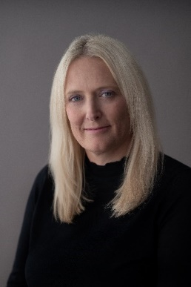

Joanna (Jo) Gilbert – Course Tutor
Jo has been a qualified Counsellor since 2013, is a registered member of the British Association for Counsellors and Psychotherapists (BACP) and specialises in adolescent, couple, and family counselling. Jo is also a clinical supervisor for other counsellors.
Jo works within the Person-Centred approach as a core modality and integrates Systemic Therapy.
She has worked within a charity setting for 10 years providing one to one counselling for young people as well as group family sessions and works for Relate. She also runs a private practice.

Jo sometimes also teaches on the other levels of training at NCCS

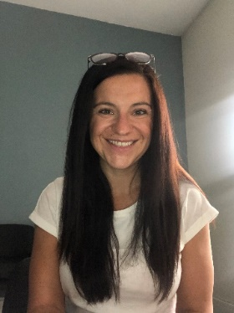

Other Staff: We also have various other staff involved in the course, including group supervisors and guest speakers.

Course Dates
The next Level 3 course will take place:
- Tuesday evenings (6-9pm)

The course will start on 10th September 2024 and will take place over one academic year.
Each year of the course will run in accordance with Northamptonshire school term dates.
The following tables outline the terms dates.
Year 1 (2024/25) | Start Date | Half Term Holidays | End Date
Term 1 | 12th September 2024 | 29th October 2024 | 17th December 2024
Christmas Break
Term 2 | 7th January 2025 | 18th February 2025 | 1st April 2025
Easter Break
Term 3 | 22nd April 2025 | N/A | 20th May 2025

Fees and Payment Options
Total Cost - £1389 (£1200 course fee plus £189 CPCAB fee)
For both payment options, a non-refundable deposit of £300 is payable within 7 days of receiving an offer of a place on the course. If the deposit is not received within 7 days, the place will be made available to other applicants.
After the payment of the deposit, either: -
- Payment of £1089 in full at least 6 weeks prior to the beginning of the course or:
- Payment of 6 instalments. Instalment 1 - £339 (£150 course fee plus £189 CPCAB registration fee). Installments 2-6 - £150/month. This is to be paid by the 10th day of each month using Go Cardless (information about this will be sent). Terms and conditions apply.
Ts & Cs apply to all options
For all options, should you withdraw from the course or be asked to leave the course early, the total course fee outlined above remains payable.
Additional Costs
- 6 hours of personal therapy (some counsellors offer student rates)
- Mandatory course textbook
- Printing

Additional Learning and Support Needs
One of the five NCCS core values is ‘Inclusivity and Accessibility’ for all students, and we take this very seriously.
It can sometimes be the case that a student has additional learning needs. This might be to support with numeracy and/or literacy or with conditions such as dyspraxia, dyslexia, sight and hearing problems, emotional and mental health conditions. Learners may also have physical/health needs that may affect their learning experience. Most of these needs will be identified at your course interview but this might not always be the case and some needs can emerge during the training course.
NCCS is a small private training centre and so, unlike a Further Education College or University, we may not have the necessary resources to be able to fund your requirements or to reasonably provide the resources that you need. If you wish to train at NCCS and you have additional needs then you need to carefully consider whether a small, private training centre is suitable for you. Additional costs incurred could include specialist equipment, specialist tutor costs, extra tutorials outside of course time and so on.
It is the responsibility of a course applicant to disclose any disability, mental health conditions or anything else that may create a barrier to undertaking a Level 4 diploma course. You are required to stated explicitly what your supports needs are and how these may have been addressed on previous training courses. You will be asked about this at interview and should you have additional needs, we will have a conversation about any ‘reasonable adjustments’ that could be made.
If a specific need emerges once the course has begun, then we will arrange an additional tutorial with the student to see what can be done to support the student, including any ‘reasonable adjustments’ that can be made.
We always do our best to support students in any way that we can, but this will be within the remit of ‘reasonable adjustments’ in accordance with the Equality Act 2010.

Frequently Asked Questions
Why should I choose courses offered by NCCS?
NCCS is an award-winning training centre that provides robust, expert-led, high-quality counselling training courses that are approved provided by the Counselling & Psychotherapy Central Awarding Body (CPCAB). The CPCAB is a UK-based awarding body that is managed by professional counsellors, trainers and supervisors and are the only awarding body in Europe to specialise in the field of counselling.
CPCAB has grown to become the UK's leading specialist awarding body in counselling. Their success is based on their commitment to developing competent counsellors - they are the only awarding body run by counsellors for counsellors.
The CPCAB provide a coherent progression route to becoming a practicing counsellor in both a counselling agency, private practice and beyond to becoming a counselling supervisor. Undertaking CPCAB courses provides the necessary guided learning hours required for counselling accreditation should a practicing counsellor wish to undertake this in the future.
I have a psychology degree; can I use this as a contribution towards my counselling training and apply straight for Level 4?
Undertaking a psychology degree and counselling training are two different things.
While both cover similar aspects in relation to theory of personality, a psychology degree is a knowledge-based qualification which requires a high level of academic ability. This is compared to counselling training which is a relational activity which depends on personal qualities, self-awareness, and soft skills such as the ability to build a trusting relationship, work with difference and diversity and covey empathic understanding.
These aspects of counselling training are not included or assessed in most psychology degree programmes and must be learnt and developed in a very different learning context. You will need to start with the Level 2 Certificate in Counselling Skills (CSK-L2).
Do I have to start at Level 2?
If you have already gained counselling skills and theory qualifications with another awarding body, NCCS will look at the number of guided learning hours (GLH) undertaken in a classroom and what the course comprised of in relation to the learning of theory and practical skills practice. This will be compared to what is covered on the Level 2 course at NCCS.
To start at Level 4, potential students will have completed equivalent skills and theory courses comprising of at least 180 GLH
If you are unsure whether this relates to you then please contact NCCS and we will arrange a telephone conversation with you
At NCCS, online or distance learning courses that do not contain live teaching or regularly assessed skills practical sessions will not be accepted as recognised prior learning.
Can I train to be a counsellor via distance learning?
In a world where counselling is an unregulated profession, there is a wide range of training available and there is a place for distance learning or online courses, usually for Continuous Professional Development (CPD) once the formal counselling training has been completed or when combined with high-quality classroom-based learning (e.g. The Open University/CPCAB Foundation Degree)
Good quality counselling training has a solid relational foundation at its core and NCCS believe that in the first instance, this cannot be achieved via online or distance learning that doesn't involve live, synchronous teacher or regularly assessed skills practice sessions
NCCS offers CPCAB courses which all incorporate regular live teaching and assessed skills practice sessions (either in the classroom or online) and provide the benefits of an environment that consists of experiential learning building counselling competence as each level of training is undertaken.
Professional membership bodies such as the British Association for Counsellors and Psychotherapists (BACP) or the National Counselling Society (NCS) require counsellors to register on an Approved Voluntary Register by the Professional Standards Authority (PSA). To do this the membership bodies and PSA insist that a proportion of the would-be counsellor's training is provided by live teaching.
BACP state: "We believe that practising counselling skills under supervision, and with feedback from staff and fellow students, is an important aspect of training. Online and distant learning courses can offer an introduction to the use of counselling skills and theory, but do not have this relationship with staff and other students".
Any online or distance learning courses undertaken that are not synchronous and don’t involve live teaching will also not count towards the training hours required for profession membership or accreditation should this be undertaken in the future once practicing.
At NCCS, online or distance learning courses that do not contain live teaching or regularly assessed skills practical sessions will not be accepted as recognised prior learning.
What funding is available for courses?
As a private training centre, funding in the form of learning loans and remitted fees are not available. However, to help spread the cost an instalment payment option is available once the deposit has been paid.
What is ScoPEd?
ScoPEd stands for Scope of Practice and Education and is a “shared standards framework, developed by six Professional Standards Authority accredited bodies….” including the BACP and NCS.
The aim of the framework is to, “provide those seeking the services of counsellors and psychotherapists who have adopted the framework with clear information on core training, practice and competence requirements so that they may make informed choices.”
It sets out, “a shared understanding of the training and practice requirements associated with different entry and progression points for the profession, and the core competences required for safe and ethical practice for counsellors and psychotherapists working with adults”.
The aim of the framework is to set out the minimum core training, practice and competences a therapist can evidence in their practice.
How does this affect trainee counsellors?
The framework is deemed to be a resource that supports the integration of generic standards at the core of a counsellor’s practice and our Level 4 diploma meets all the requirements for access to Column A.
Our courses also meet almost all the requirements for access to Column B. You will complete at least 100 client hours in a counselling placement as part of your diploma training which will leave a further 250 hours to complete before being able to access column B by undertaking the accreditation process of the professional body you are a member of. Almost all the academic requirements of column B will be met by the Level 4 diploma course.
Impact?
The framework has only recently been adopted by the professional membership bodies involved and so the impact of the framework remains to be seen. It can currently be utilised as a guide for all therapists to transition to the column of their choice.

